***Northeast Illinois Volkswagen Association Membership Application***

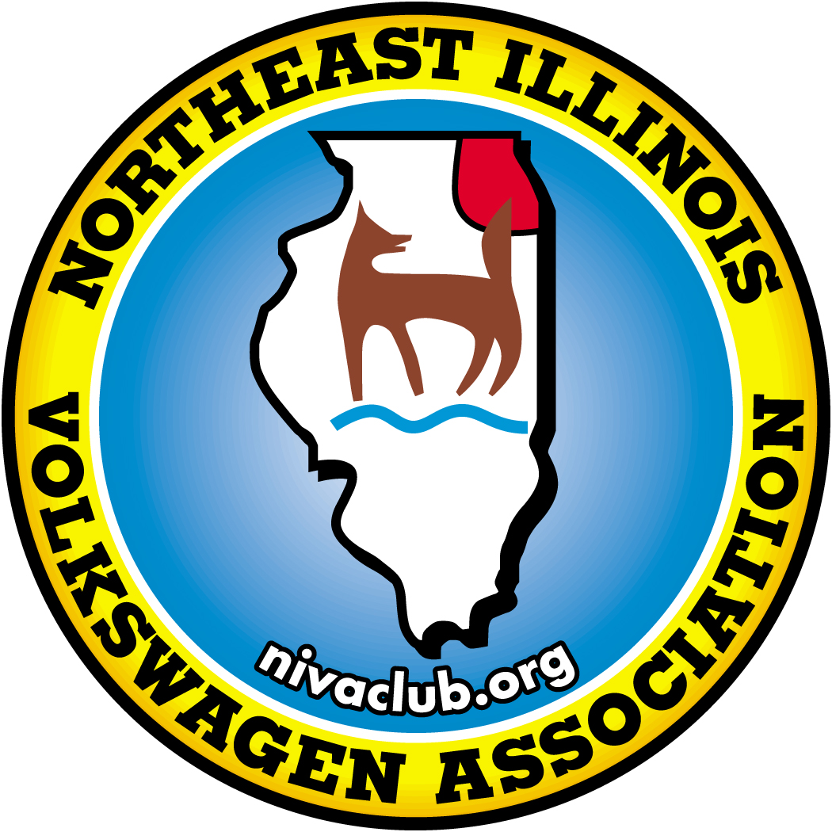

NIVA membership is just $30.00 for the first year and $25.00/year thereafter. Since NIVA is a chapter of the Volkswagen Club of America, you will also become a member of VWCA. Annual dues cover the cost of club mailings, PO Box, website, etc.

Please fill out the information below, attach a check made payable to Northeast Illinois Volkswagen Association and mail to:

**NIVA Club Membership**

**PO Box 3387**

**Lisle, IL 60532**

Name:___________________________________________

Address:_________________________________________

City, State, Zip:____________________________________

Phone:____________________

E-Mail:___________________________________________

VW’s Owned:______________________________________

Interests:

___Car Shows ___Rallyes ___Tech Seminars

___Swap Meets ___Parades ___Cruise Nights

___Family Outings ___Camping ___Picnics

___Customizing ___Restorations

**For More Information, E-mail** [**info@nivaclub.org**](mailto:info@nivaclub.org)

**Find us at** [**www.nivaclub.org**](http://www.nivaclub.org/) **and** [**www.facebook.com/nivaclub**](http://www.facebook.com/nivaclub)